

DESIGNATED ROUTES

- The following two (2) routes are designed for Units to select from when participating in the Unit Wellness Walk event for Summer Sports Day 2026. When selecting the route, it is imperative that the Team Captain considers the fitness levels of their participants and the time available to the Unit to conduct this activity.

- Each route varies in length and can easily be modified to have Units start and finish at their Unit location, if preferred. Exact distances covered can be easily measured by employing GPS technology.

- Option 1: Open the Gate (Round Trip 4.4km)

- this is an out and back route starting at the Col J.J. Parr Sports Centre, with the turnaround point at 4 Wing Gateway Park (i.e., “the Jets”).

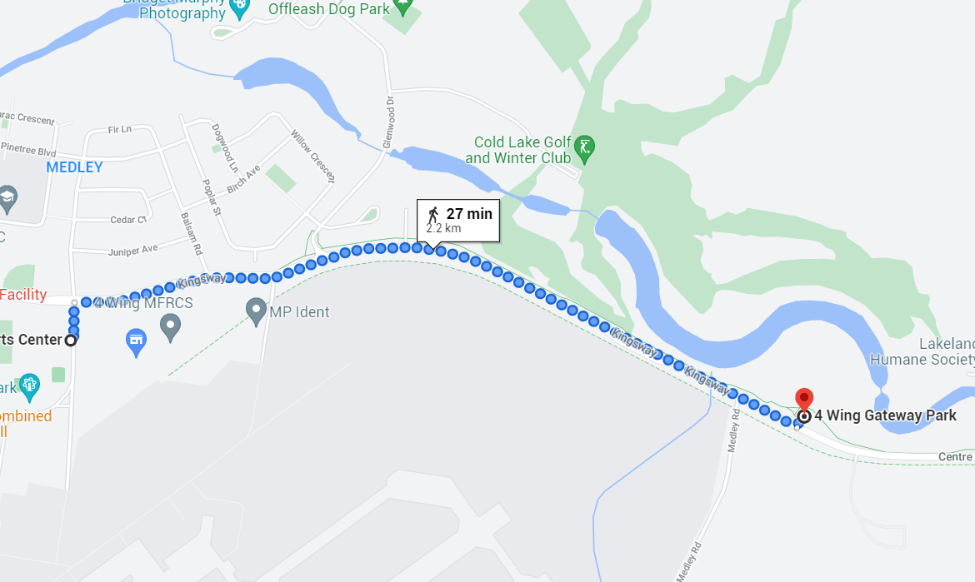
Potential risks: road/lane use (intersections); sidewalk access; traffic

- Option 2: Phys Ed at Martineau (4.1km)

- This is a loop route starting at the Col J.J. Parr Sports Centre, looping through the Martineau area, before returning to Col J.J. Parr Sports Centre.

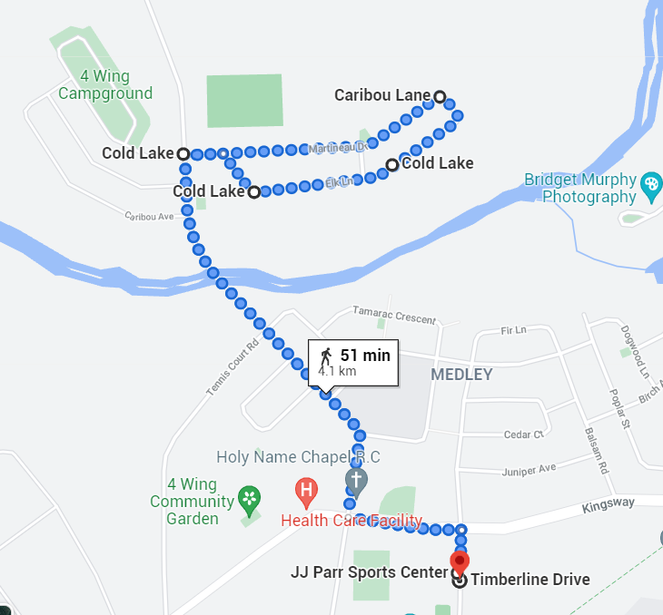
Potential risks: road/lane use (intersections); sidewalk access; uneven/adverse terrain; traffic – vehicles and other pedestrians

